2023

2023

**Roper Corporation**

**Mobility Routine**

**2021**

Joint health is helpful to encourage optimal muscle and nerve function. For this reason we strongly suggest you perform the following mobility exercises for **prevention** of soreness and discomfort.

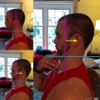

**Lower neck stretch (Retraction):** With good sitting/standing posture, draw your head back as far as possible without lifting off of bottom line (making a double chin). Return to neutral. Repeat, with each rep trying to move further back. This is a movement not a stretch so go as far as possible but stay only 1-2 seconds maximum.

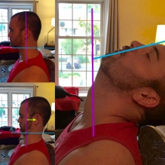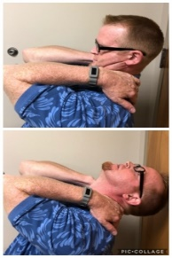

**Lower neck stretch (extension):** Place fingers at the base of neck over your trap muscles and provide support while pulling head back into retraction (see above), then lift head over hands to look at the ceiling until stretch is felt.

.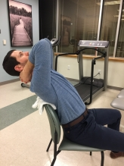

**Thoracic extension:** Clasp your hands behind your neck and bring your elbows inside. Move your elbows up and extend your spine backwards like you are sliding along the ceiling. This is a movement not a stretch so go as far as possible but stay only 1-2 seconds maximum. ***This is best done over a chair or other fulcrum. Fulcrum around shoulder blade area and lean over for full stretch.

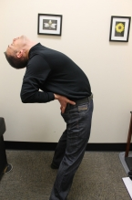

**Lumbar extension:** Standing with feet about shoulder width apart and hands in the small of lower back. Slowly bend backwards as far as possible without forcing the movement. This is a movement not a stretch so go as far as possible but stay only 1-2 seconds maximum. As you rep this out, it will be become more comfortable and less stiff. If it is too uncomfortable to do standing, you can perform this on your stomach- example later in this packet.

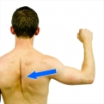

**Shoulder extension stretch:** Draw your arms back behind your waist as far as you can. Keep your elbows straight. You can also clasp your hands behind your back and push down and back (first picture). Make sure you are squeezing your shoulder blades down and together while lifting your chest up.

**Shoulder blade squeeze:** FIRST pull your chest and head up like a string is pulling you toward the ceiling. Then with elbows bent, squeeze your shoulder blades DOWN and together. Hold 1-2 seconds and repeat.

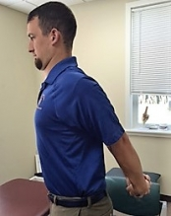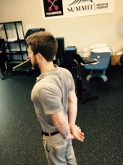

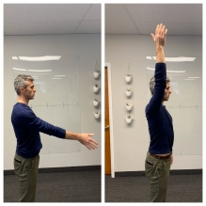

**Overhead reach:** Start with upright posture, bring arms overhead within comfortable range. Lower and repeat. Start in mid-range, progress to end range. Perform in thumbs up position.

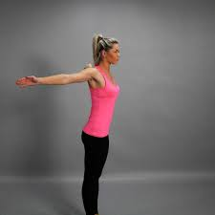

**Arms outstretched:** Bring arms out to the side, opening up the chest. Can lift the chest and pull fingers back further for an added stretch.

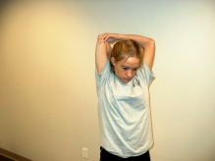

***Please seek assistance if you have any concerns or discomfort while attempting the******exercises.***

**Overhead back stretch:** reach arm behind back to scratch shoulder blade (same side, not opposite). Reach as far as you feel comfortable. Return and repeat 5-6 reps. You can choose to hold it for a shoulder and tricep stretch.

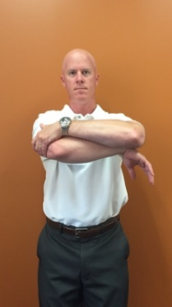

**Horizontal Adduction:** Bring arm to be stretched across your body. Grasping the elbow, gently pull the arm to be stretched across the body until a comfortable pull is felt behind the shoulder. If discomfort is felt in front of the shoulder, lower the arms slightly and repeat.

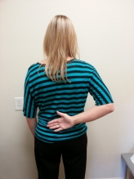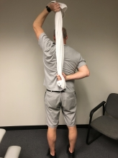

**Shoulder internal rotation:** In standing, bring your hand to the middle of your low back then lift as high up the spine as you can, then back down. This is a movement not a stretch, so repetitions are encouraged rather than holds. Stay only 1-2 seconds maximum. You can also use a towel, belt, or leash to assist with this stretch.

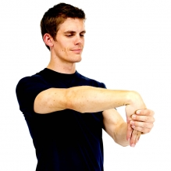

**Wrist flexion/forearm stretch:** Start with elbow bent at your side, reach fingers toward the floor for a few reps then straighten elbow and repeat. You can progress the stretch by adding overpressure and turning fingers/hand out to the side.

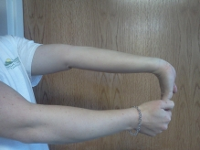

**Wrist extension/forearm stretch:** Start with elbow bent, rotate thumb facing outward, reach fingers toward the floor for a few reps then straighten elbow and repeat. You can progress the stretch by turning fingers/hand in and adding overpressure.

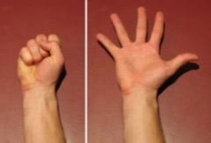

**Hands open wide:** spread fingers wide until a gentle stretch is felt. Perform periodically throughout the day during micropauses.

Considerations/general recommendations:

* These movements are best performed as a repetition and not a hold. We recommend doing 3-5 reps of each movement as part of your morning warm up.
* Midrange vs End range vs Overpressure
  + It’s best to move joints into the end range of motion. Let off, then repeat. If this is uncomfortable, start with just mid range movements. Overpressure is when you push into the joint for a stretch- optional if you feel you need it.
* Frequent and strategic micropauses.
  + Interrupt positions with opposite directions to prevent fatigue or stress from accumulating. This can be remarkably effective.
  + Example: If bending forward or looking down a lot, take a second or two to lift your chest/extend your upper spine. Even if it is just a “micropause”.

**If you don’t use it, you lose it. Check your motion often.**

**Additional/alternative mobility for neck, upper back, and shoulders**

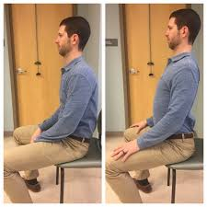

**Cervical/Thoracic rotation:** In seated position, move slowly through full, pain free range of motion. Try to feel stretch in mid to upper back around shoulder blades. Gently reverse to starting position, repeat. This is a movement not a stretch so go as far as possible but stay only 1-2 seconds

**Slouch/overcorrect:** While sitting on edge of chair, sit slouched, then overcorrect and sit as upright as possible. Hold for 5 seconds then return to starting position. On the last repetition during the full upright position, relax 10-20% so that it is more comfortable to maintain-- this is ideal sitting posture.

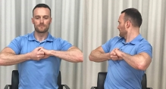

**Lateral neck flexion:** Sit up tall in a chair. Keeping your shoulders down and your eyes forward tilt your head towards one shoulder. Gently reverse to starting position, repeat. This is a movement not a stretch so go as far as possible but stay only 1-2 seconds. **To address pain on one side of neck, try moving TOWARD/INTO the pain first rather than stretching away.

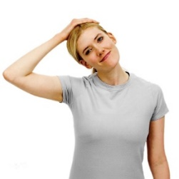

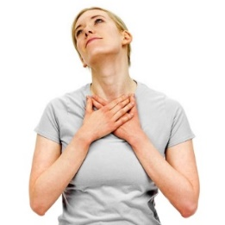

**Neck flexor stretch:** Place hands over your breastbone or clavicle. Tilt head upwards and away from side you want to stretch. Hold 5-10 seconds and release.

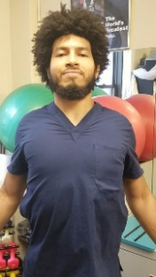

**Shoulder rolls:** Shrug your shoulders straight up, then slowly roll them backwards, pulling shoulder blades down toward your hips. Can roll in a circle backwards, then forwards

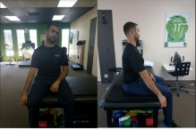

**Self Shoulder Traction**

While sitting, grab the corner or side of a chair or bench. Slowly lean away from that side until you feel a gentle stretch in the shoulder joint. Repetitions are recommended rather than long holds.

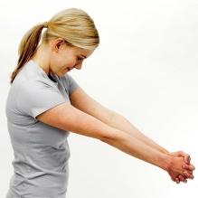

**Upper/middle back flexion stretch:** Interlace fingers then pull your hands forward until a stretch is felt along your upper back

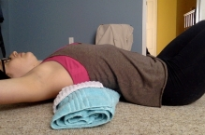

**Mid back extension stretch:** Lying with a tightly rolled up towel under your trunk (around shoulder blades or a little lower), bring arms directly overhead into a Y position, out to the side in a T position or with hands clasped behind the head. You can relax in this position for 3-5 minutes.

**You should feel a little extension stretch in the mid upper back, as well as a chest stretch almost near the armpits.**

**Gradually increase tolerance to prolonged time in position (2-5 minutes) as it can create some short term soreness when it is first started.**

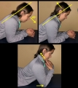 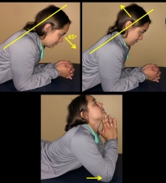

**Lower neck extension:** Lay on stomach and prop up on your elbows, move head back into retraction as instructed at the beginning of packet. Perform as a repetition or hold for a gentle stretch. If you feel really loose and want to get an added stretch, lift head up AFTER you are in full retraction. Note arrow instructions.

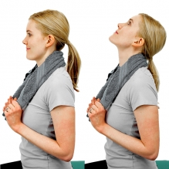

**Mid neck extension:** use a towel (or the hood of your hoodie) to support the mid part of your neck as you extension your head up to the ceiling. This should be performed 5-10 reps and no holds. This is helpful for neck pain and for some people with frequent headaches.

**Additional/alternative mobility for low back and hips**

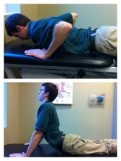

**Prone Pressups:** Lie down on your stomach with your hands in a pushup ready position. Push your upper body up and straighten your elbows; try to leave your hips on the table. This motion will extend your back. Return to the starting position.

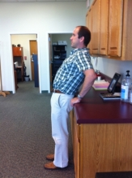

**Low back stretch over fulcrum:** Use a supported surface as a fulcrum for a low back extension stretch. This tends to be more effective as you age compared to unsupported lumbar extension. Use as a repetition NOT a stretch- meaning lean back to the end of the range of motion and return to standing, then repeat.

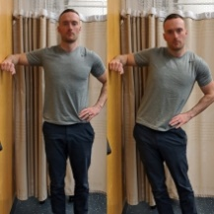

**Sideglides:** Shift hips to one side using your hand as guidance to the end of range of motion then return to midline and repeat.

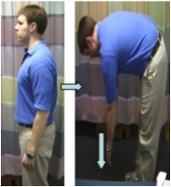

**Spinal flexion:** Slowly bend forward vertebra by vertebra as far as you can without pain trying to reach both hands towards toes. Keep knees straight and you should feel a small stretch in your lower back. NO PAIN *Always follow this up with a few reps of lumbar extension*

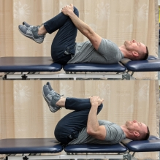

**Knees to chest:** While lying on your bed, slowly bring your knees towards your chest then relax the pressure. Perform 5-10 times in a pressure on, pressure off fashion.

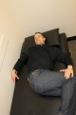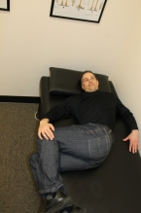

**Flexion with Rotation:**   
1. Lying on your side bring your knees towards your chest.  
2. Slowly lower your top shoulder backwards toward the surface.  
3. Take a deep breath...exhale...and slowly allow yourself to relax deeper into the twist position.  
**Note:** if you are experiencing back pain on one side, it’s helpful to perform this with painful side down. (ex- if R low back is hurting, lay on R side, and turn upper body to the left)

If you feel an increase in your symptoms bring your shoulders up so you are no longer in a twisted position. Try adjusting your knees up or down and resume the twisted position by allowing your shoulders to go back again.

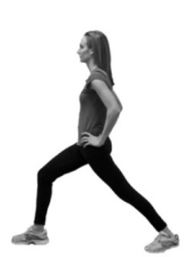

**Hip external rotation stretch:** While sitting in a chair, cross your leg with the ankle of one foot on the knee of the other.  
Next, push the top knee downward for a stretch.  
Push and release for a self mobilization. Repeat 5-10 times.

**Hip extension:** Hold onto the wall if needed. Bring one leg backwards and lean hips forward while leaning chest backwards until a stretch is felt in the front of the hip. This can be performed as a stretch or a mobilization/repetition.

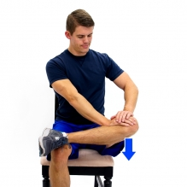

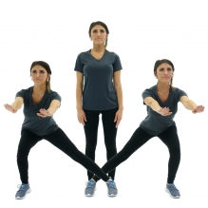

**Weight shifts:** Shift your weight to each leg. Options- spread your feet and lunge to the side. Or simply shift back and forth on your toes alternating heel lifts.

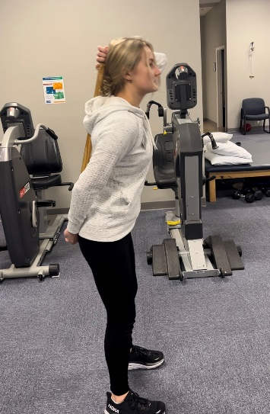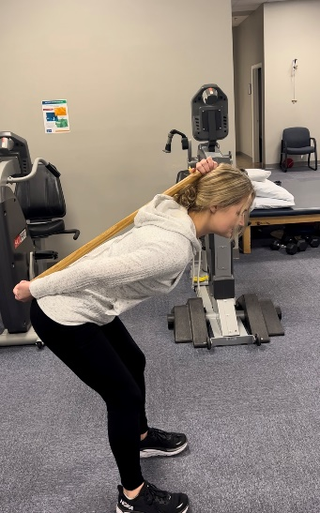

**Hip hinging** can be extremely helpful to train your body how to properly bend and squat. Use a broom or stick to maintain your form. Keep it in contact with your head and your tailbone as you bend forward and/or perform a minisquat. If you practice this daily, you will start naturally moving in ways that reduce injury and pain.

**Additional/alternative mobility for wrists/hands**

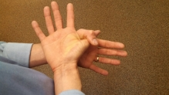

**Carpal Tunnel Stretch:** Position self as shown. Gently pull the thumb outward and down to stretch the tissues. Can be performed as a repetition or stretch. Pull to gently stretch x10 reps or Hold 10-20 sec.

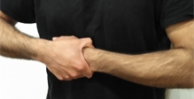

**Wrist self traction:** Use your other hand to pull on the wrist of one hand – in the same direction as your forearm

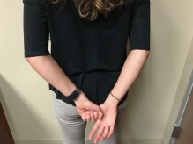

**Weight bearing wrist stretch**: Start on a counter or table and progress toward the floor if desired. Start with palms down and shift weight side to side and in circles. Change your angle by turning fingers forward or to the side.

**CMC Distraction:** With hands behind back, grasp entire thumb firmly with opposite hand. Relax arms, and allow the weight of your arms to pull on right thumb. Make it a habit to rest your arms in this position.

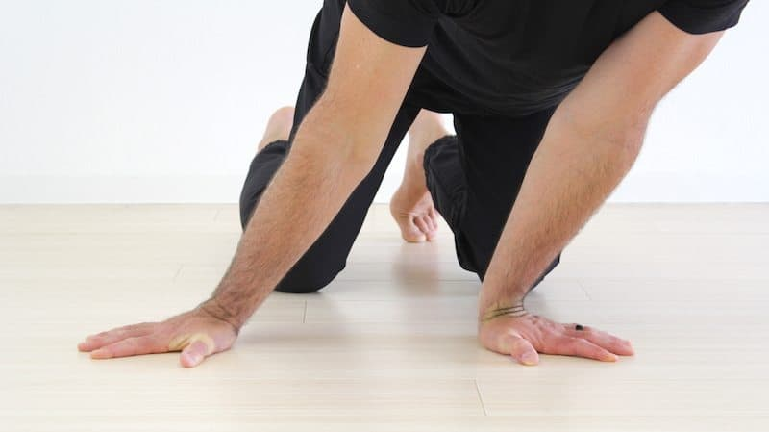

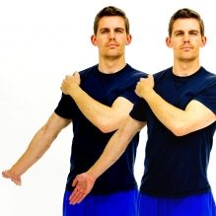

**Nerve glides**: Start with your arm hanging down at your side with your elbows straight and palm facing forward. Next, bend your wrist back to feel the stretch in the fingers/palm/forearm. This is a nerve GLIDE not a stretch so go as far as possible but stay only 1-2 seconds. Repeat.

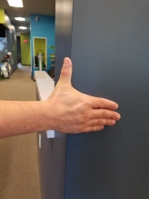

**Inner thumb stretch**: stabilize your thumb against the wall. Slide your fingers and palm away from thumb until you feel a gentle stretch in base of thumb and palm.

**Additional/alternative mobility for knees/ankles/feet**

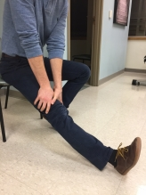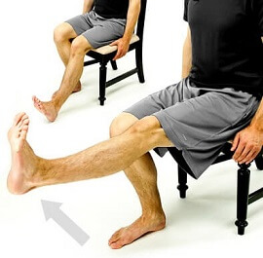

**Knee extension:** While sitting on edge of chair, place heel on ground with leg straight out. Tighten thigh muscle in order to fully straighten knee. For further stretch, place hands above knee and push towards the floor. Alternative- bring lower leg up and tighten knee/quad. Repeat.

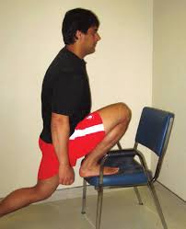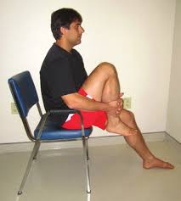

**Knee flexion:** Place foot in chair and bring bottom towards heel to feel stretch in knee. Move into the stretch, back off and repeat. Do not hold. Can also perform seated if this is uncomfortable.

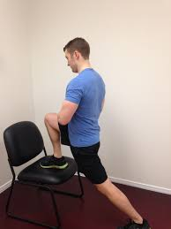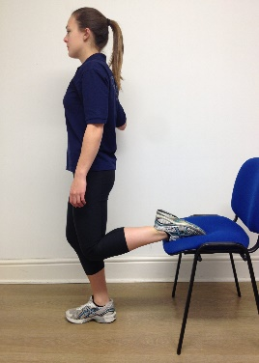

**Plantar fascia stretch/great toe stretch:** Move ankle/foot up first then pull toes up to stretch fascia at the bottom of the foot. Can also perform on the wall as demonstrated in second picture.

**Ankle dorsiflexion/plantarflexion:** Place foot in chair and lean forward until stretch is felt in ankle or calf. Move into the stretch, back off and repeat. Do not hold. **Ankle plantarflexion**: Place foot in chair as demonstrated in second picture and lean into stretch until felt in top of ankle/foot. Can perform both stretches seated by bringing foot under chair.

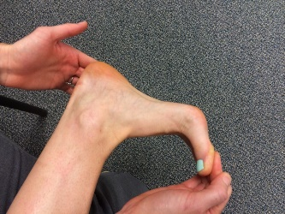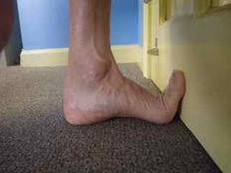

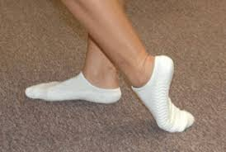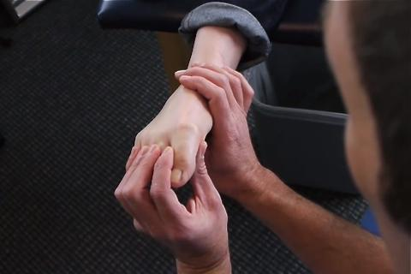

**Great toe plantarflexion:** Can perform sitting or standing- rock into the stretch. Second picture- perform manually if desired- move the joint into the stretch then release. 5-10 reps.

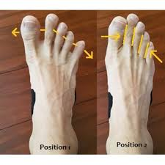

**Toe spreading/squeezing:** Bring toes out away from each other, then squeeze them together. This gets easier with practice and focus. Foot control is important as you age for strength, mobility and balance.

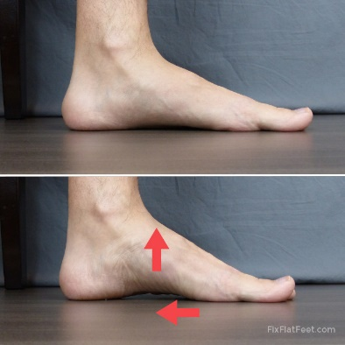

**Arch lifts:** While sitting or standing, draw arch up without curling your toes. If this is too hard initially you can start by curling your toes or scrunching a towel. Then progress to performing arch lift with toes flat. This is incredibly important for mobility and strength in your feet.

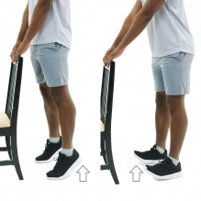

**Heel/toe lifts:** Use support if needed, then lift up your heels coming up on your toes. Optional- You can then rock back on heels and lift toes. Performing this throughout the day will be helpful to wake up your foot and calf muscles, as well as decrease foot and heel soreness.

*These stretches are general recommendations for musculoskeletal health and prevention of workplace discomfort but may not be appropriate for all individuals. They should be performed pain-free. Please seek assistance if you have any concerns or discomfort while attempting the exercises. Modifications are available.*